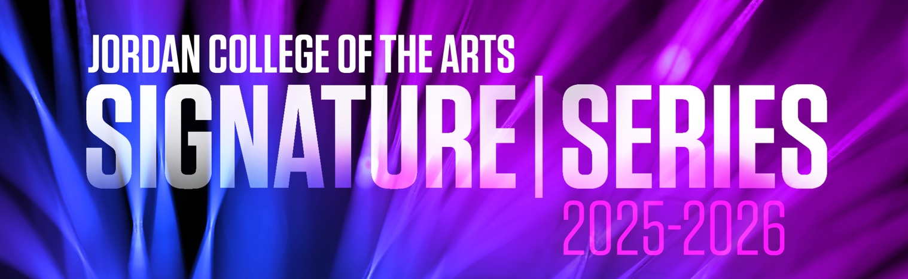
Sandeep Das: Delhi to Kabul
A kaleidoscopic journey of music, storytelling, and dance

Wednesday, September 3, 2025
7:30 pm, Schrott Center for the Arts
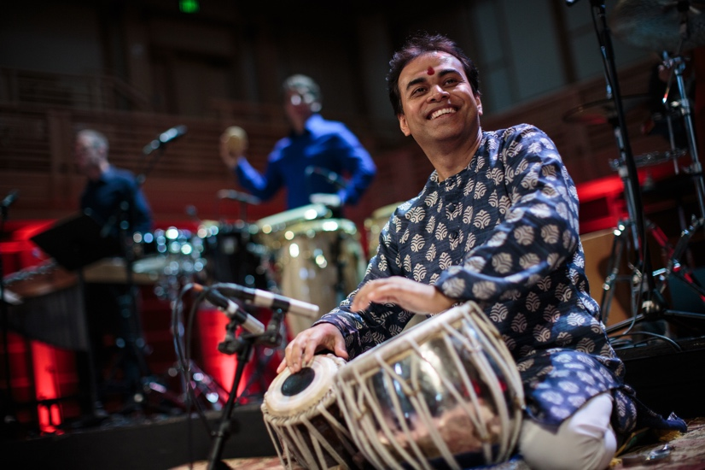

Sangeetam paramanandam shanta rasa pravartakam, a Sanskrit shloka, means music is the ultimate bliss and the creator of peace and tranquility. Delhi to Kabul is the fourth initiative* under Sandeep Das’ Transcending Borders One Note at a Time (TBONT) project, which aims to harness that transformative power of music and inspire positive social change through a variety of mediums including performances, residencies, community engagement activities, and talks/presentations. Das’ vision of bringing together music traditions from across the world has produced an eclectic repertoire that is simultaneously deeply rooted in tradition and yet uniquely innovative.

With a focus on the arts of India and Afghanistan, Delhi to Kabul is a kaleidoscopic journey of music, dance, and storytelling that showcases the shared heritage of two countries that are as ancient as they are modern, and as diverse as they are captivating.

This evening’s program will feature iconic instruments from each country: the tabla (a pair of hand drums from North India), rabab (a lute-like instrument from Afghanistan also common to many Central Asian countries), and sitar (string instrument from India) are joined by Kathak dance (a classical storytelling dance from India) and a narrated story by Afghani author Homeira Qaderi.

*Other TBONT projects include: Delhi to Damascus, Delhi to Shiraz, Delhi to Istanbul, Delhi to Kabul

— SELECTIONS TO BE ANNOUNCED FROM THE STAGE —
“Sanawbar” by Homeira Qaderi
This story was commissioned by Sandeep Das and Dartmouth College for the world premiere of Delhi to Kabul in April 2023. It is Homeira Qaderi’s reimagination of Kabuliwala, a short story by the famous Bengali author/poet, Rabindranath Tagore, who was also the first non-European to win the Nobel Prize for Literature.

A musical adaptation of Sanawbar will appear in the concert.


To read the full story, you can scan the code below with your phone’s camera or visit www.sandeepdas.com/tbont

ABOUT THE ARTISTS

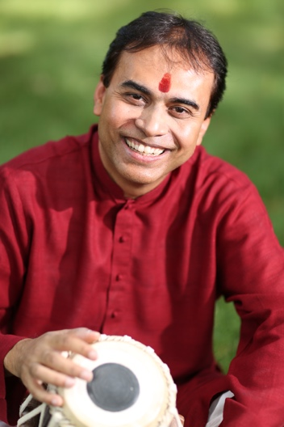
SANDEEP DAS, Tabla
Hailed as a “creator of myths with Houdini-like skills” (The Sydney Morning Herald, Australia), Sandeep Das is one of the leading Indian Tabla virtuosos in the world today. A disciple of the legendary Pt, Kishan Maharaj ji of the Banaras Gharana, he debuted at the age of 17 with renowned Sitar maestro Pt. Ravi Shankar ji and went on to lead a prolific international career that now spans more than three decades. He has collaborated with top musicians and ensembles from across the globe such as Yo-Yo Ma and the Silk Road Ensemble, with whom he has performed for the past 21 years, as well as Paquito D’Rivera, Bobby McFerrin, and iconic orchestras like the New York Philharmonic, Boston Symphony, and Chicago Symphony, among others.

A Grammy winning-musician and Guggenheim Fellow, Das’ groundbreaking new music projects sit at the crucible of ancient tradition and modern innovation, enchanting audiences worldwide with “flawless playing” (Songlines Magazine, U.K.) and a “roadmap for irresistible aural adventures” (Downbeat Magazine, USA). His original compositions have been performed in over 50 countries at venues like China’s Forbidden City Concert Hall, Australia’s Sydney Opera House, and the Hollywood Bowl in Los Angeles, California. Transcending Borders One Note at a Time, his most recent project, was launched in 2020 to widespread international acclaim, and seeks to harness the power of music to catalyze positive social change.

Driven by a vision for a brighter future, Das is the founder of Layālaya, a nonprofit arts organization in the US that creates arts experiences that connect people across time, place, and culture. In India, he founded the nonprofit Harmony and Universality through Music (HUM), which has promoted global understanding through music performance and provided learning opportunities and scholarships for visually-impaired children with artistic potential since 2009. He is also an active public speaker, and has presented at The New York Encounter, The EG Conference, TEDx events, and multiple university residencies. In 2015, he established Das Tabla School, where he currently trains musicians from 6+ countries both online and in-person in Boston, MA. To learn more about him, please visit www.sandeepdas.com.
QAIS ESSAR, Rabab
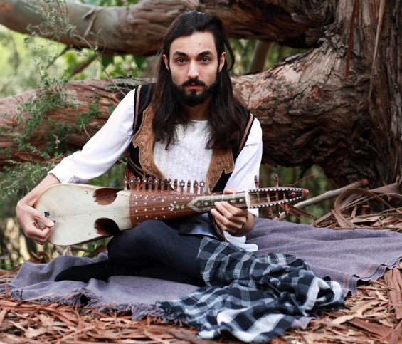
Qais Essar is a contemporary Afghan composer, instrumentalist, producer, and rabab player. He has toured extensively, sharing his music nationally and internationally. He has composed pieces for the 2021 Oscar-nominated film, Three Songs for Benazir (2021), as well as the Golden Globe and Oscar-nominated film, The Breadwinner (2017), and received a Canadian Screen Award for “Best Original Song” for his piece The Crown Sleeps. Essar continues to be featured in festivals and venues around the world including the Newport Folk Festival, SxSW, The Kennedy Center, Treefort Music Festival and more.

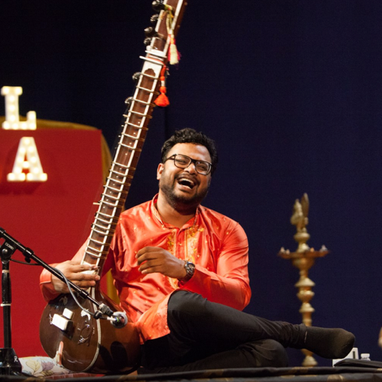
RAJIB KARMAKAR, Sitar
Rajib Karmakar is a Los Angeles-based performing artist, composer and educator who combines tradition with innovation to create new forms of musical expression. He received his musical training in sitar from Pt. Durgadas Karmakar and Pt. Ramdas Chakravarty, and in Vocals from Ustad Ghulam Akbar Khan. Drawing from this deep grounding in Indian Classical Music, Rajib’s projects involve performances across the globe and work with studios such as Sony, Warner Brothers, Dreamworks, and Disney. He is the founder and current director of the Los Angeles International Music and Arts Academy, and has collaborated on several world music projects such as Dhara, Wahh World Fusion, Loop Science, and Nada Naissance.

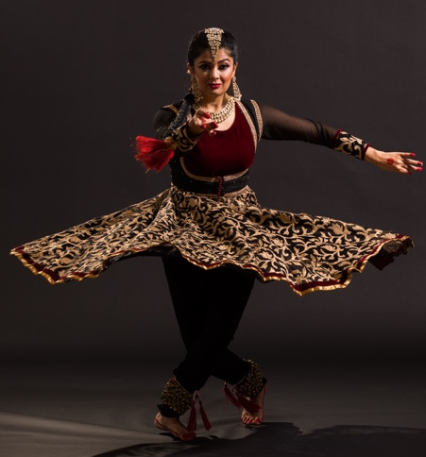
ANTARA BHARDWAJ, Kathak Dance
Born in India, Antara Bhardwaj is a dynamic Indian Classical artist specializing in Kathak dance. She began her study of Kathak with her Guru, the late Pandit Chitresh Das, at the age of nine and spent many years studying one-on-one with him in the traditional ancient Guru-disciple tradition. She went on to become a Kathak soloist, a member of the internationally renowned Chitresh Das Dance Company, a teacher for the Chhandam School of Kathak, and the founder of her own dance company and school, Antara Asthaayi Dance. A lifelong student, Antara continues to develop her mastery of taal (rhythm) under the guidance of her rhythm Guru, Pt. Sandeep Das.

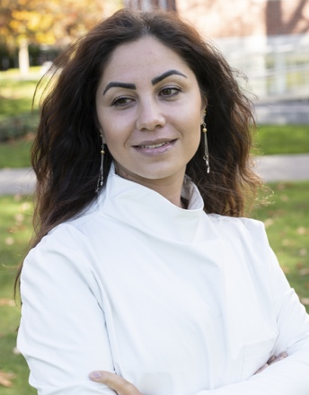
HOMEIRA QADERI, Short Story
Homeira Qaderi is an Afghan writer, activist, and educator. She has written seven books, including a collection of short stories and her acclaimed novel Noqra: The Daughter of Kabul River (Rozgar Publishers, 2009), and was a 2021-22 Radcliffe Fellow at Harvard University. Before leaving Afghanistan, Qaderi taught at Gharjistan University, in Kabul, and worked as a senior advisor to both the Minister of Education and, earlier, the Minister of Labor, Social Affairs, Martyrs, and the Disabled. A lifelong human rights activist, Qaderi was awarded the Malalai Medal—Afghanistan’s highest civilian honor—for exceptional bravery by the president of Afghanistan.


ELLIE HOOVEN, Student Narrator
Ellie is a senior Acting Major from Nashville, TN. Butler Theatre credits include LADY MACBETH (Macbeth), THEY DON’T PAY, WE WON’T PAY (Chorus), EVERYBODY (Love), MEN ON BOATS (Bradley), #SHAKESPEARESONNETSALIVE (deck crew), and RADIUM GIRLS (Sound Board Operator) as well as many directing projects and student productions. Ellie is also pursuing a secondary major in Strategic Communications. Her goal is to be both a stage and film actress and a PR representative for theaters and actors.

JCA LAND ACKNOWLEDGEMENT STATEMENT
We gather here at Butler University on the traditional homelands of Indigenous peoples who were forcibly removed from this place. These peoples include the Myaamiaki (Miami), Lenape (Delaware), Bodewadmi (Potawatomi), Saawanwa (Shawnee), Kiikaapoi (Kickapoo), and Peouaroua (Peoria) peoples. We honor with gratitude the land itself and the indigenous peoples past and present who have stewarded it throughout the generations. This acknowledgement calls us to commit to hearing and engaging Indigenous voices and perspectives and to being better stewards of the land we inhabit. It also calls us to action. Learn more by scanning the QR code for additional information.


Tonight’s performance is sponsored by
